User’s manual
First, we need to open the file “enabled instruction.txt”.And then copy the instruction.
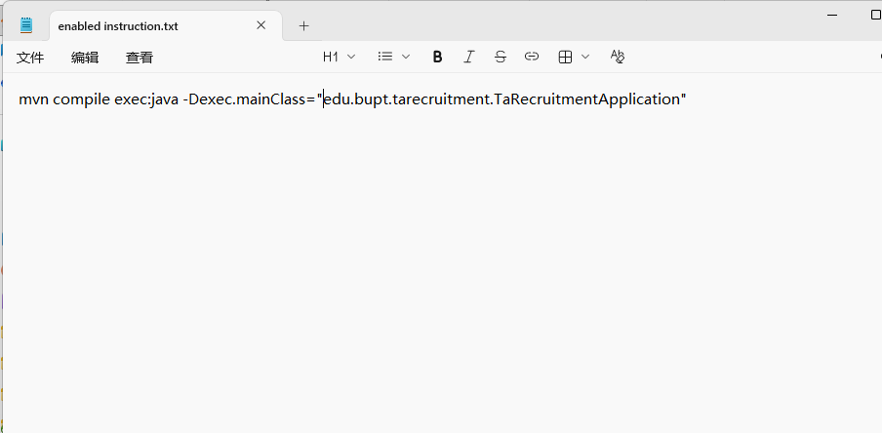
Then, open the directory where "Software-Engineering-45" is located, and enter "cmd" and press Enter (or compile and run in software such as VScode)
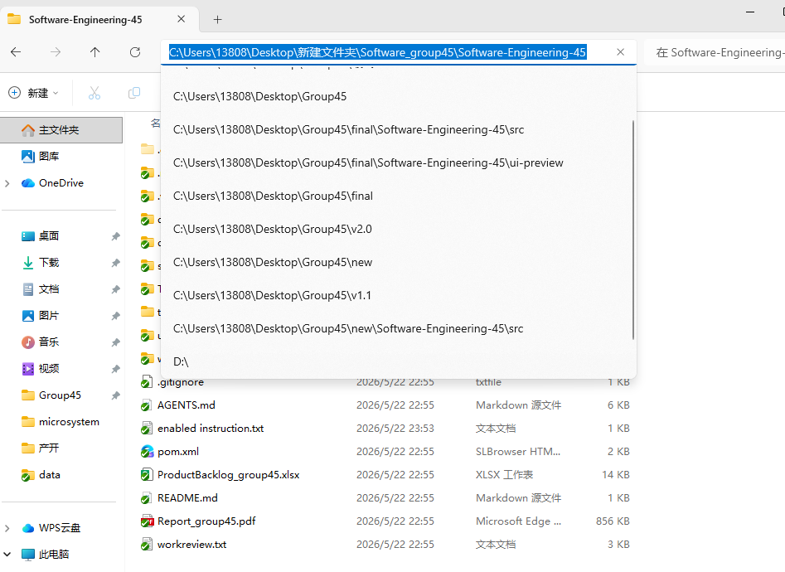

This is our login interface. You can select the character. On the left, there is one account and password for each.
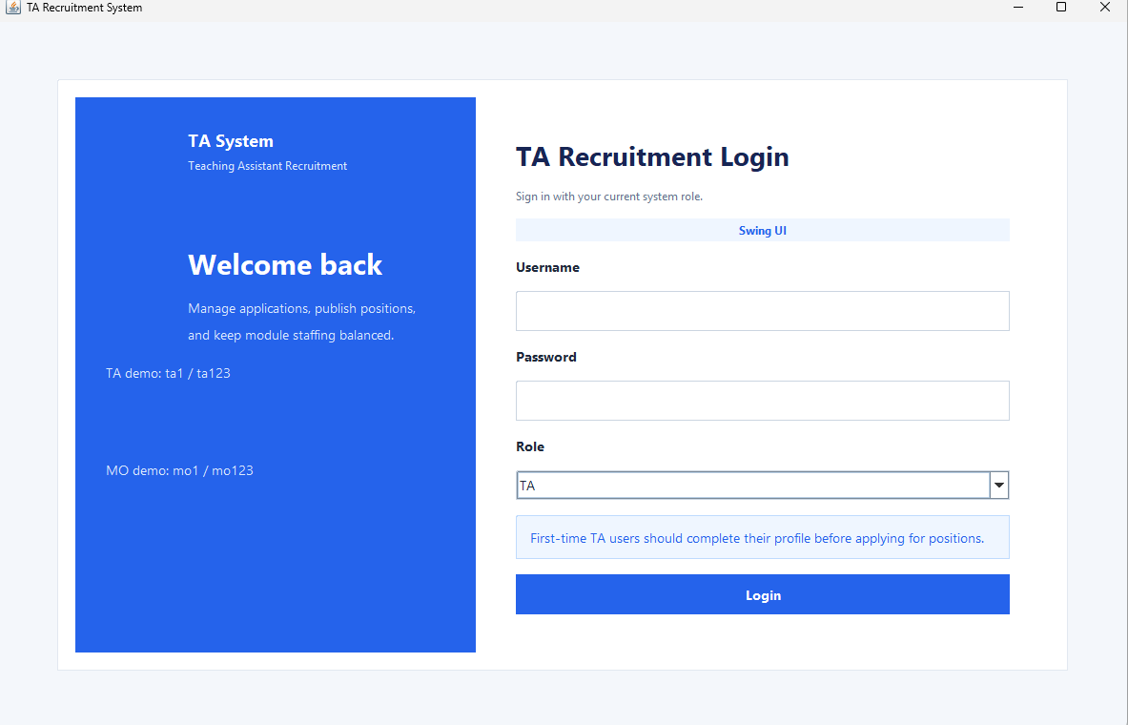
This is the main interface where TA logs in.
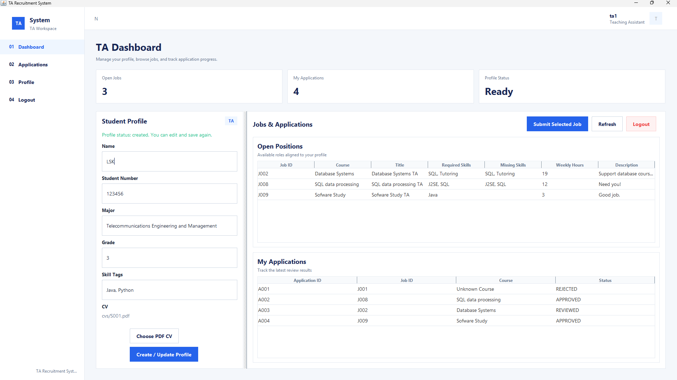
This is the selection interface for the application process. You can view the currently available jobs and the details of the jobs that have been applied for.
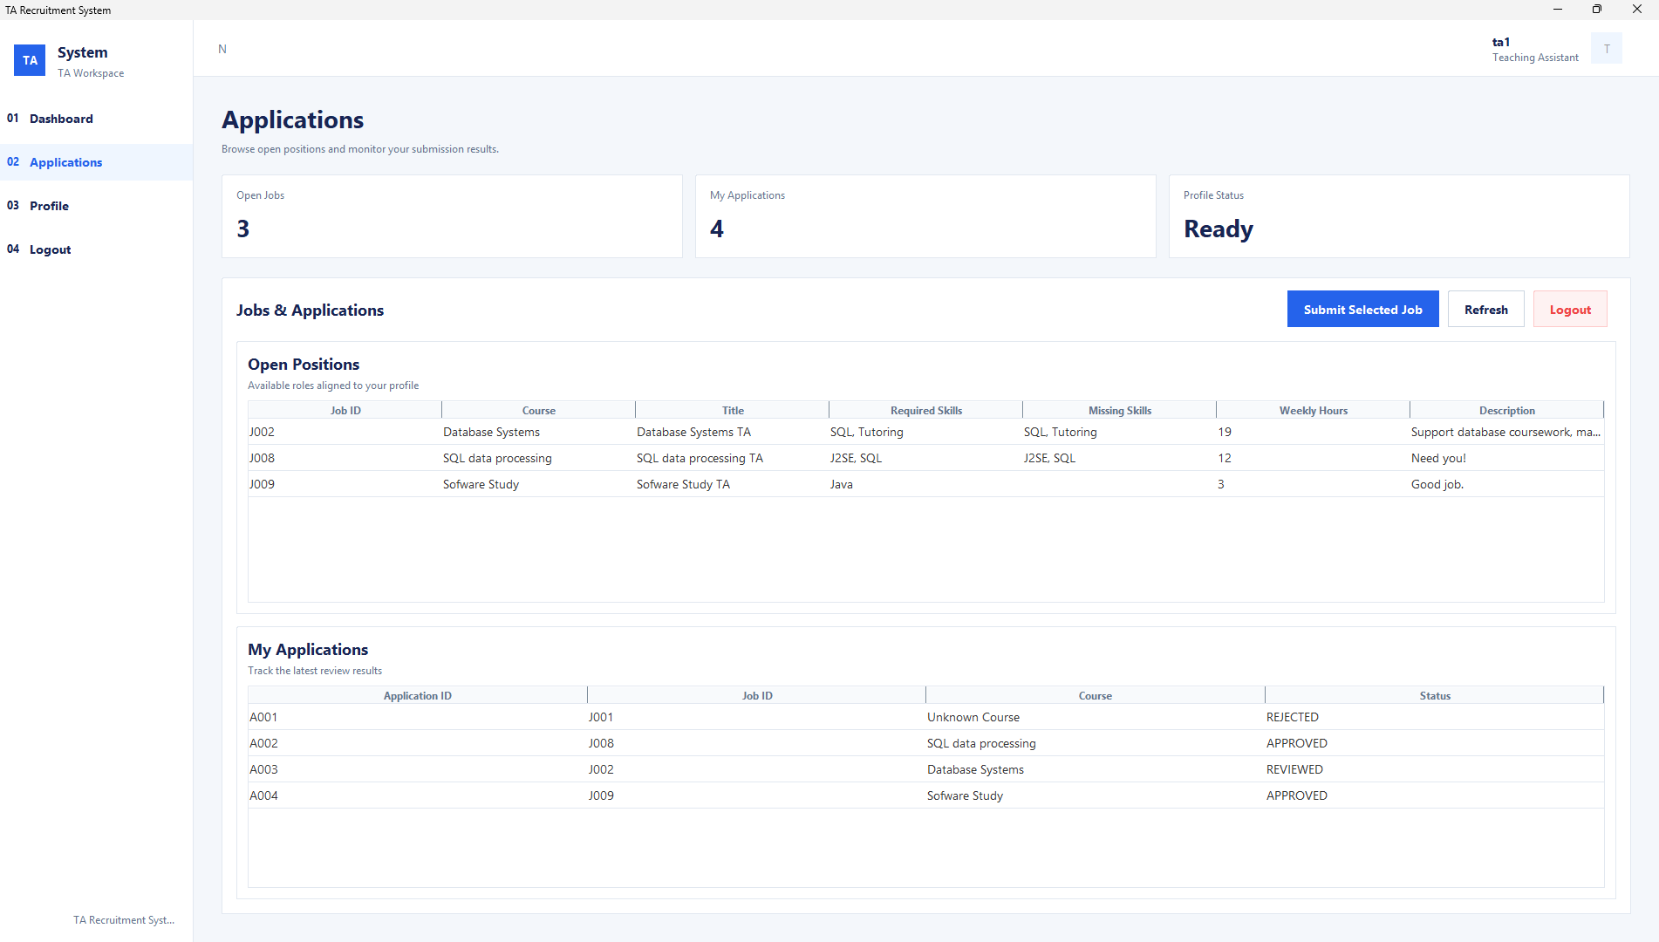
This is the interface for modifying personal information. You can make changes to your information here.
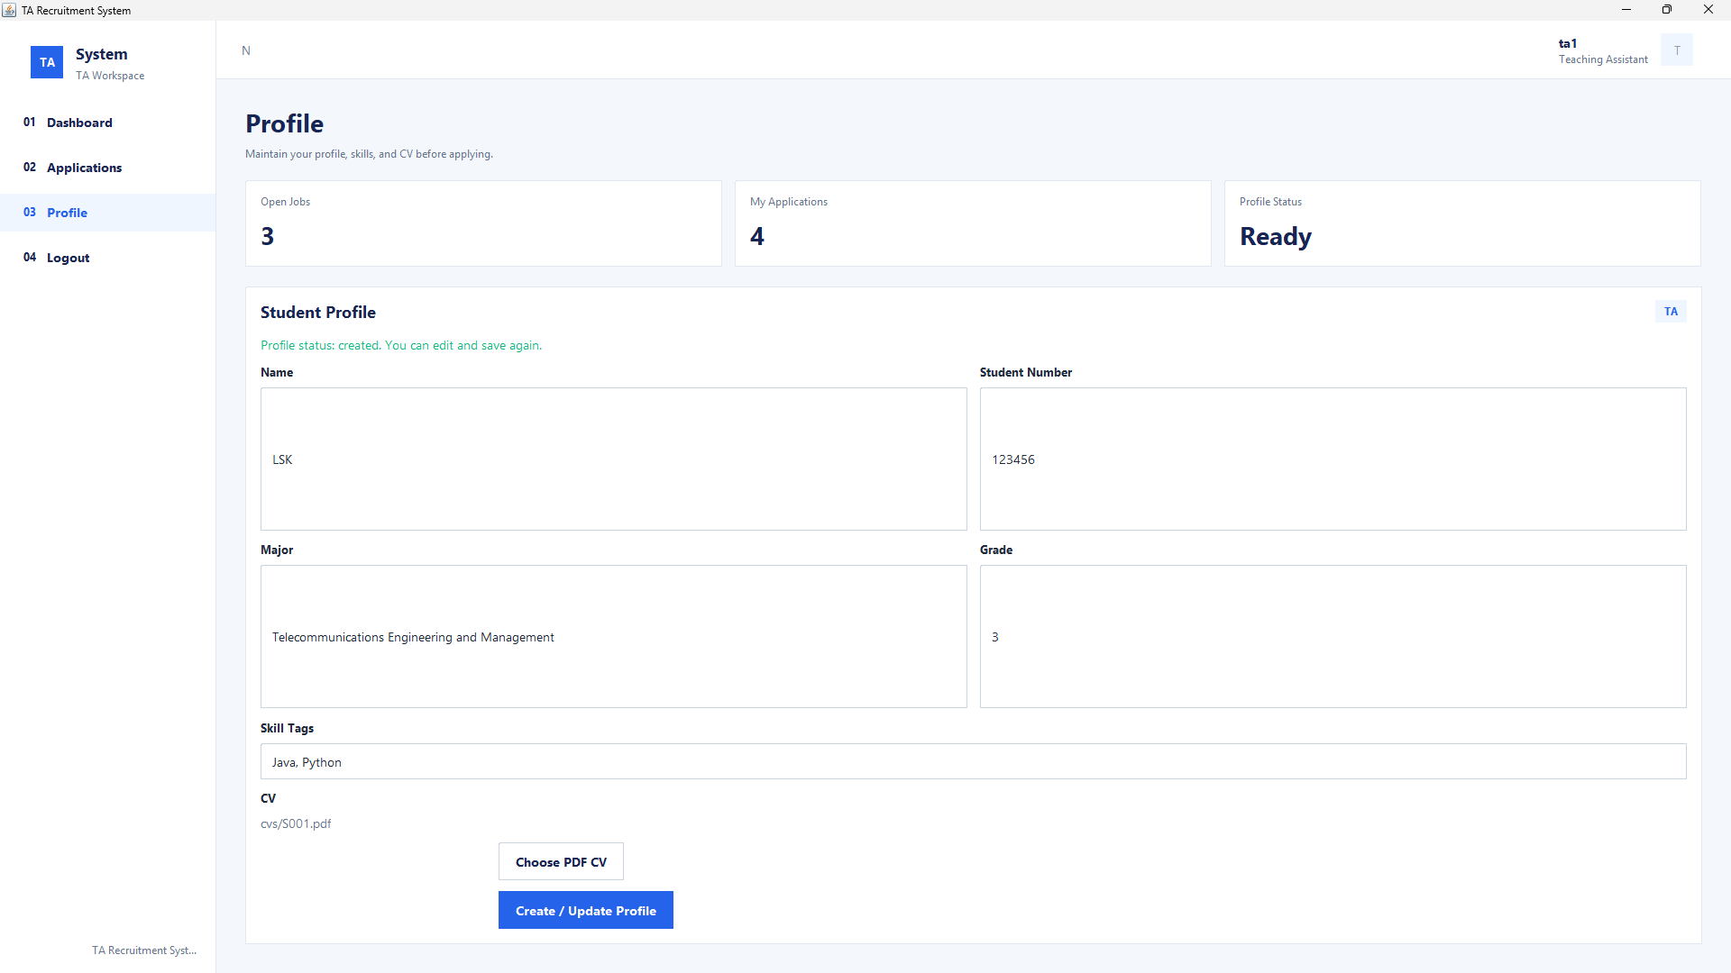
This is the main interface of MO.You can modify the job information here to update it promptly.
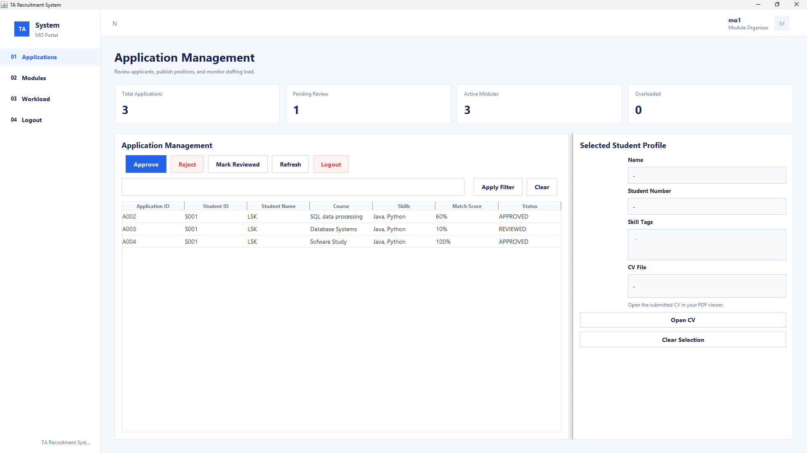
This is the interface for viewing job applications. Here, you can see the information of the student applications and make decisions such as approval, rejection, or marking to achieve efficient application processing.There are also AI tools that assist you in determining whether the application meets the requirements.
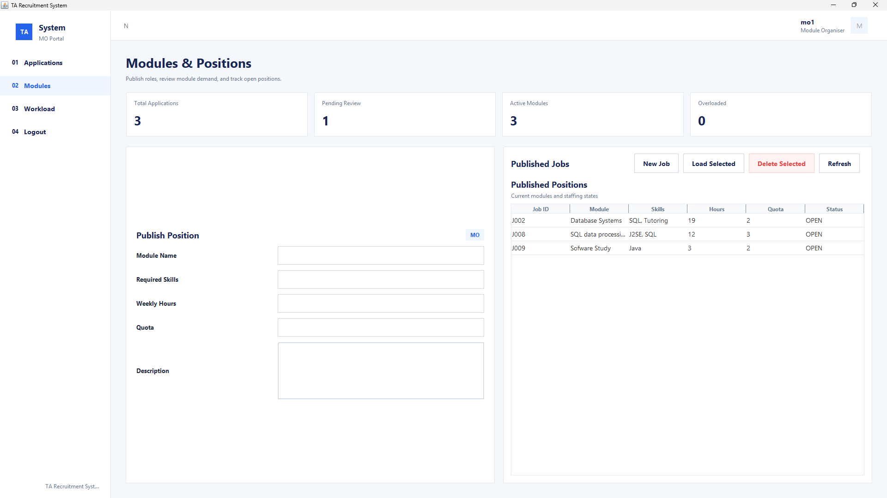

Finally, there is the monitoring of working hours. This measure can prevent the employee's schedule from exceeding the limit, thus avoiding the occurrence of dangerous situations.
